Lab 4 Assignment Shreyas GN

241059048

**LAB 4**

1. write a shell script to get value the pattern and file name from the user and check the pattern exists or not. If the pattern exists print the relavent

message , if pattern not found print relevent message.

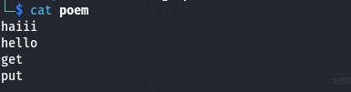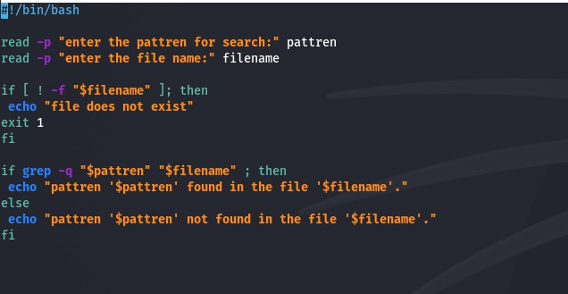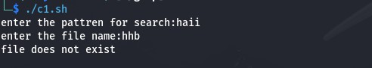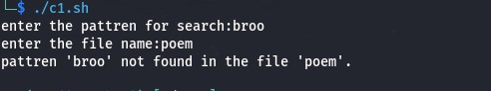

1. Modify the above script to pass the arguments from command line arguments.

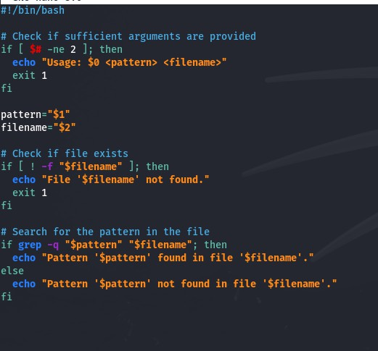A computer screen shot of a code  Description automatically generatedA computer screen shot of a code  Description automatically generatedA computer screen shot of a computer code  Description automatically generatedA computer screen shot of a computer code  Description automatically generated

1. Modify the above script to pass the values inside the script.



